**Day 1 Node Basics**

Installing Node in Operating System

* **Step 1: Download the Installer**

Download the Node installer from the official site.

* **Step 2: Run the installer.**

Run the installer and click Next until the setup wizard is complete.

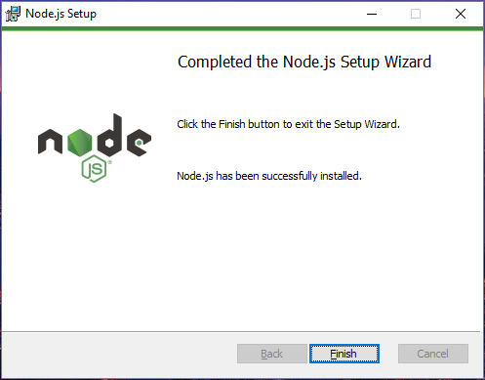

* **Step 3: Verify the installation**

Open command prompt or PowerShell and run the following command. node -v It should return the node version.

* **Step 4: Update the NPM**

**Day 2 Building Web Server**

Build a simple Web application that prints Hello World on the

browser upon user's request.

**Day 3 Node modules**

We can install node modules using node package manager or called npm.

You can also install the module and write it in your package.json file

using the following command.

You can create your own node module as well. All you need to do is

create a function and export it for the reusability.

For example, consider this code which can act as a node module.

**Day 4: Files**

1. **Read File**

You can use fs.readFile() or fs.readFileSync() method to read files

* **readFile**: Read files asynchronously (async), using callbacks to handle errors and data.

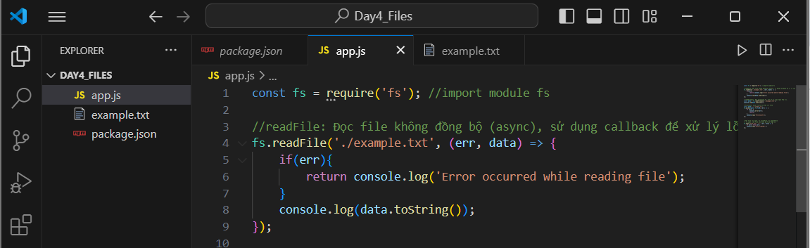

* **readFile**: Read files asynchronously (async), using callbacks to handle errors and data.

1. **Check the existence of the file**

Use fs.access to check if a file exists without taking up much memory**.**

1. **Create file (fs.open, fs.writeFile, fs.appendFile)**

* **fs.open:** Create a new file or open an existing file.

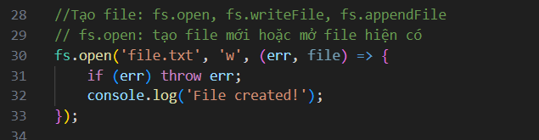

* **fs.writeFile:** Write data to the file. If the file does not exist, a new one will be created.

* **fs.appendFile:** Add data to the end of the file. If the file does not exist, a new one will be created**.**

1. **Delete file (fs.unlink)**

1. **Rename file (fs.rename)**

1. **Copy file (fs.copyFile)**

